CKMS – 2016 AGM
June 4th, 2016
Location: Waterloo Library, Main Branch, Waterloo ON
Attendance: Cam Vannatter, Jessica Becker, Tiarra Robinson, Peter Higdon, Alim Nathoo, Carmelo Furruggio, Dan Lynn, Dan Kellar, Jeff Stager, Jenniefer Stronge, Milan Majstorovic, Nat Persaud, Rob McKenna, Sean Collins, Jordan Dorans
Proxy: Adam Kras, Shannon Kavanaugh

Call to order at 2:50PM

Welcome and Introductions
Dan thanks the past board for their hard work and tough decisions focusing on the move during the course of the past year.
Agenda for AGM is displayed:
Motion to approve: Sean
Second: Rob
PASSED

SPACE
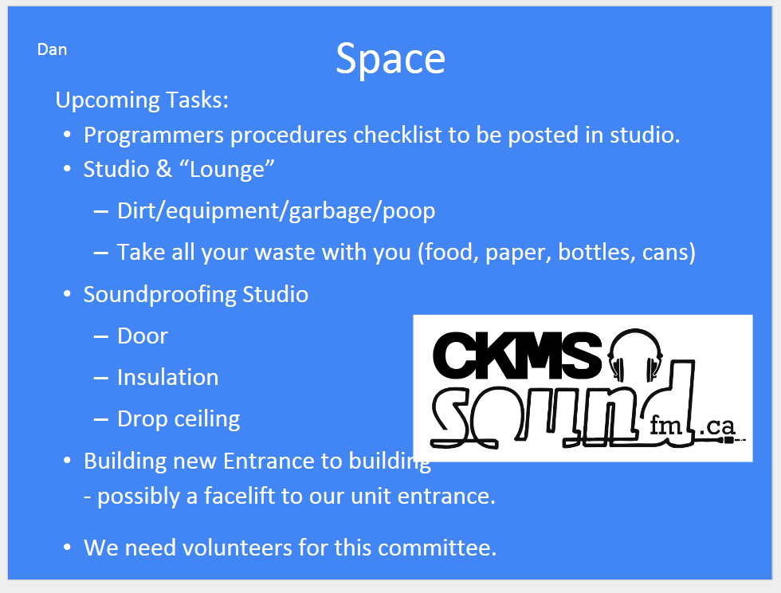
Ventilation suggested for lounge area – must wait until studio A is soundproofed.
Questions about plans for the floor at the station.

FINANCES – Dan & Rob discuss how things at the station were left.
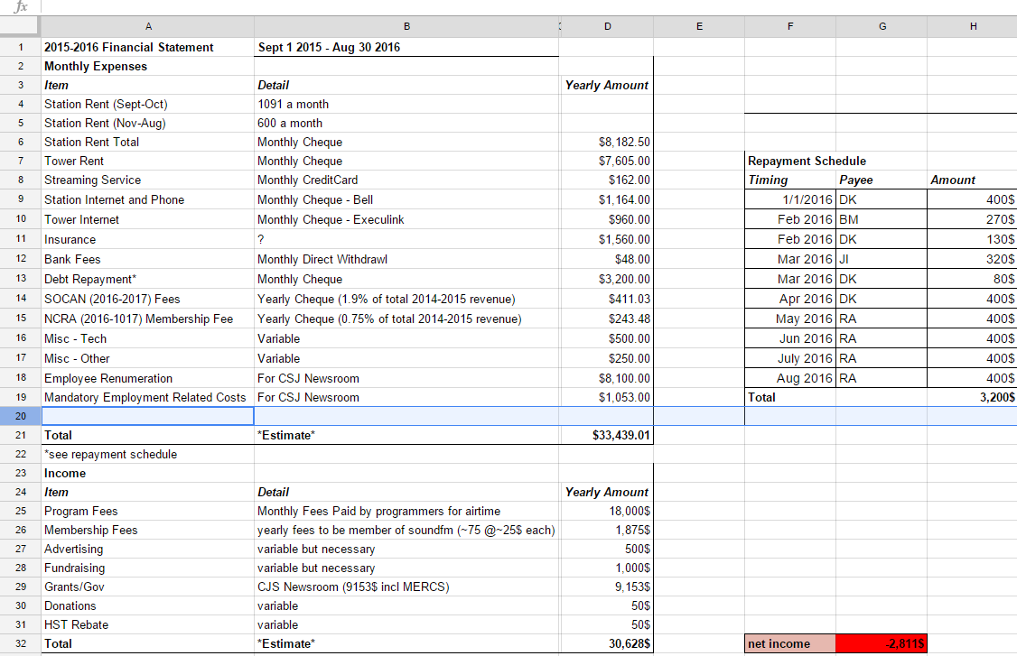
Finances Continued:
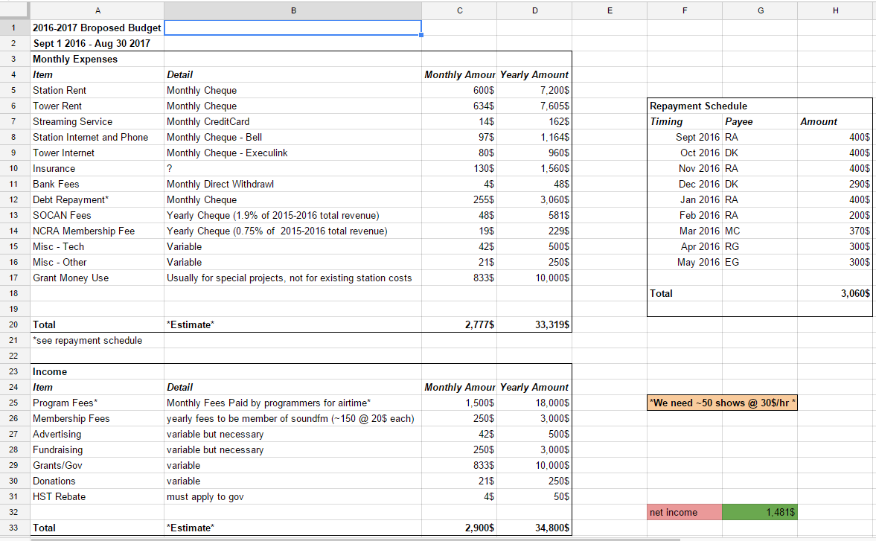
CSJ – questions what this program is? Money will be received and what will it go towards? How is it helping the station?
CRFC – grant policy is to only fund a project
Discussion of possible decrease of membership fee to $20
Questions from membership about Insurance and taxes.
Motion to approve the above proposed budget: Nat
Second: Cam
Passed

Music - Rob
This committee will pick up once the space is set up a bit better.
Jenn volunteers for Digital music submission committee
Tech – Nat
Past year accomplishments with the move discussed
Thanks to email responders who help with troubleshooting the membership
Future:
- Emergency Broadcast System
- Listener interaction
- Quality and Reliability of broadcast
Possible workshops in summer

Outreach – cam
Social media
outreach events
Contact to become a part of this

Fundraising
We need volunteers to help organize and set these up
Dawn suggests possible workshops
Nat agrees to take on Fundraising initiative
discussion of Carlo &

Programming - Rob
New programming and Incentive Program reviewed. This program was already approved at the last board meeting and is now being presented to the membership.

Policy Ratification
- Defining “Member in Good Standing” in Sec 3 (Membership)
Add - 3d) A member in good standing has paid their membership for the year. If the member is also a programmer, they must have up to date show finances or an approved payment plan in place with the program director.
Vote: Approved

- AGM Timing Change in Sec 5.
Change a) The Annual General Meeting of the Corporation shall take in the spring of each year and shall be held at such a place as designated by the Board of Directors (hereinafter “the Board”).
To - a) The Annual General Meeting of the Corporation shall take place annually within 3 months of the end of a fiscal year. The meeting shall be held at such a place as designated by the Board of Directors (hereinafter “the Board”).

Nat Notes that the AGM is intended to approve the next year’s budget
Amended:
a) The Annual General Meeting of the Corporation shall take place annually within the 3 months prior to the end of a fiscal year. The meeting shall be held at such a place as designated by the Board of Directors (hereinafter “the Board”).
Approved

3) Conditions on Head office Location in Sec 2
Change 2 from - The head office of the Corporation shall be within the city of Waterloo, in the province of Ontario.
To - The head office of the Corporation shall be within the Region of Waterloo, in the province of Ontario.

Approved

4) Changing Quorum for board meetings in Sec 7
Change the first sentence of 7a) from - A quorum for the transaction of the business of the Corporation shall be four (4) Directors.
To - A quorum for the transaction of the business of the Corporation shall be six (6) Directors.
Rob – what if the board of directors only has 5 members sitting on the board. Nothing will ever be accomplished.
Amended: A quorum for the transaction of the business of the Corporation shall be more than 50% of the board members.
Approved
5) Updating voting rules on removing a director to reflect a larger board (Sec 14).
Change 14f from - During any meeting of the Board, the directors may, by a majority vote of at least five (5) of seven (7) Directors, choose to strip any Officer of their position as an Officer of the Corporation.
To - During any meeting of the Board, the directors may, by a majority vote of at least eight (8) of eleven (11) Directors, choose to strip any Officer of their position as an Officer of the Corporation.
Rob – Same issue as #4
Amended: During any meeting of the Board, the directors may, by a majority vote of at least 70% of the Directors, choose to strip any Officer of their position as an Officer of the Corporation.
Approved

Members Forum
Dan wanted to note the CSJ community newsroom program which starts up on Monday
Jeff Stager notes that AWS – for podcasting needs a better payment plan and steps to upload.
Dawn: has questions about co-ops and anti-oppression policy
Jeff stager: notes that the studio computer is loud.

Board Elections:
Dan, Cam and Moses are returning
Nominations:
Dan nominates Jessica and Rob
Rob nominates Jenniefer, Nat, Carmelo, and Jeff Stager
Cam nominates Tiara, Pete and Dan
Pete declines.
Voting not needed since there are enough openings
Asked to new members if anyone would prefer the 1 year term. Jessica and Jenn take the 1 year term.

